- Question 1
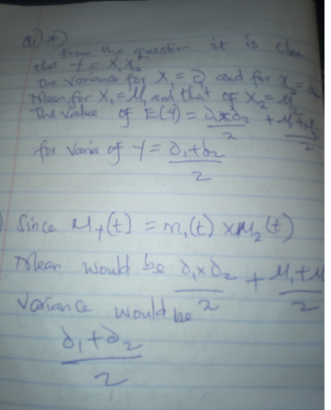
2. Solution
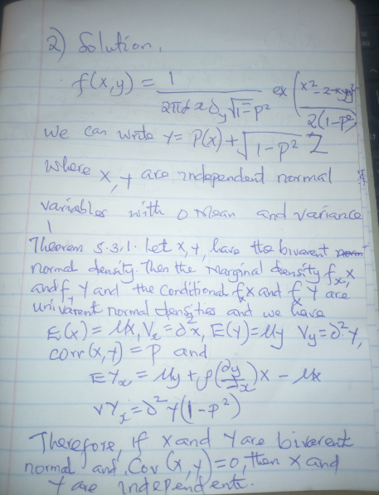
Question 3
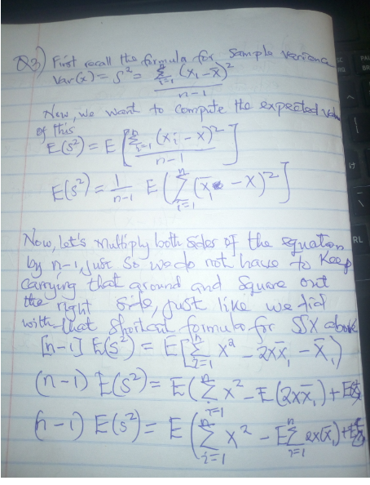

Question 4 Solution

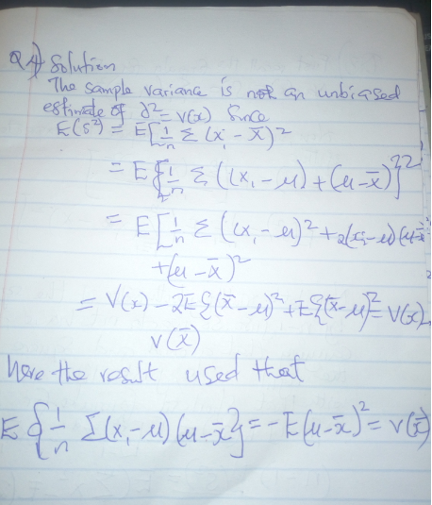
Question 5 Solution
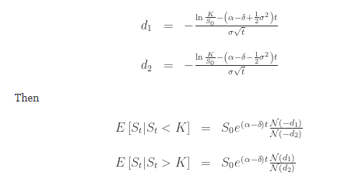
Since this is a scaled and shifted square of a standard normal variable, it is distributed as a scaled and shifted chi-squared variable.
- The distribution of the variable X restricted to an interval [a, b] is called the truncated normal distribution.
- (X − μ)⁻² has a Lévy distribution with location 0 and scale σ⁻²

